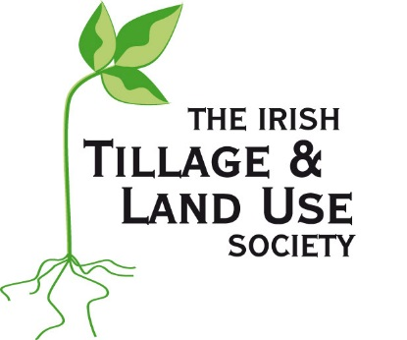
ITLUS / Rosenbohm
US Farm Internship

This farm internship aims to provide international farming experience to a person involved in agriculture in Ireland. The award will provide up to one season of work experience and accommodation on a large US farm located in northwest Missouri. The winner will be hosted by the Rosenbohm family who will provide the recipient with practical experience in the production, husbandry and marketing of corn and soyabeans, as well as in the processing of soyabean seed.

Who can apply?
Applicants must be at least 20 years of age to apply for this internship. Applicants must be resident on the island of Ireland and be a member of either the Irish Tillage and Land Use Society (ITLUS) or the Ulster Arable Society (UAS).

What experience will the winner get
This is a large maize and soyabean farming business and the intention is for the recipient to experience up to a full season of crop production -- establishment, growth, harvesting and marketing. This farm is also a big soyabean seed assembler, both GM and non-GM. The recipient would gain experience in the growing, harvesting, storage and processing of these crops.
The host farm family will provide accommodation for the award winner during the internship. In general the winner will be expected to provide his/her own food but some meals may be provided during busy times.
The recipient will be expected to gain knowledge of crop management. The host will make every effort to ensure that the intern receives a very diverse work experience and has an enjoyable stay in the US.
The award winner is expected to work along with management, family and other employees at different times and so must be prepared to work long hours during busy spring planting and fall harvesting periods.

Requirements
Be over 20 years of age on 1 January 2018.
Available to travel to the farm in Missouri for a period between late March and late November 2018.
Be a member of ITLUS or UAS.
Reside on the island of Ireland.
Hold a current full driving license.
Have a knowledge of working modern farm machinery.
Have, or be in the process of acquiring, a qualification in agriculture.
Have agricultural work references.
Be sociable and willing to interact with people.
Recipient will be expected to provide a synopsis of experiences gained.
A farming background is not essential.
The winner must be able to successfully obtain a visa to work in the US.

Terms and Conditions
- This farm internship is open to residents of the Republic of Ireland and Northern Ireland, aged 20 years or over on 1 January 2018.
- Applicants must be a member of either the Irish Tillage and Land Use Society (ITLUS) or the Ulster Arable Society (UAS).
- The winner must be in a position to confirm their identity and eligibility. Failure to do so will disqualify them from the farm internship.
- The farm internship award is not transferable to a third party.
- The winner will be notified as soon as possible after 1 February 2018. If there is no response from the winner within one week of contact being made, the winner will forfeit his/her rights to the next in line of the chosen finalists (and so on until a winner has been contacted).
- By submitting an application, the applicant is indicating his/her agreement to be bound by the terms and conditions of the farm internship programme.
- Completed entry forms must be posted to: ITLUS Secretary, C/O Eugene Ryan, Ballycarroll House, Portlaoise, Co. Laois.
- The closing date for receipt of entries to the competition is 5.30pm on Friday, 26 January 2018.
- The decision of the judging committee will be final.
- The Irish Tillage and Land Use Society (ITLUS) and the Ulster Arable Society reserve the right to cancel or amend the farm internship without notice, and for any reason whatsoever.

Application and selection process
The 2018 application form is available on the ITLUS (www.ITLUS.ie) and UAS (www.ulsterarablesociety.org) websites. This must be completed and returned to the ITLUS secretary before 26 January 2018. Follow-up interviews will take place in the weeks following.
An initial screening of applications will take place by a selected committee based on the qualifying criteria. This committee may select a shortlist of the qualifying candidates to be called for interview.
The interview process will question the capabilities of the applicants and their suitability as an ambassador for ITLUS/UAS, Irish farming and Ireland. It will also focus on the competency of the applicant with regard to the processes involved in crop husbandry, crop management, communication skills, self sufficiency etc. The interview will also seek to assess the ability of the applicant to slot into the work programme and ethos of the host family.
Where the suitability of a potential winner is uncertain, it will be necessary to consult with the host farmer with regard to a potential winner. The committee may also consult with reference providers.
While it is the intention of ITLUS/UAS to make an award on an annual basis, this might not be possible every year if a suitable candidate is not found or if it does not suit the host farmer.

Selection committee
ITLUS President
Irish Farmers Journal
UAS Representative
ITLUS Council member
Industry representative
ITLUS member / Previous recipient

The award winner
The purpose of this award is to provide an opportunity to an Irish person to experience US farming by working on a large US farm. The potential recipient must be in a position to spend at least part of a season (9 months maximum) in the Mid-West of the US for the duration of the internship.
The winner will get the opportunity to learn about the production of maize and soyabeans and to encounter the business challenges of farming in the US. The winner will also gain experiences in the processing of seed crops and in the marketing of grains. Other areas of expertise may also be possible.
It is hoped that the winner will remain involved in the Irish tillage sector in Ireland and that the experiences gained may be used to help others in our tillage sector. It is hoped that the winner will provide occasional reports of his/her experiences to the Society during the internship and present a report of the experiences at a future ITLUS conference.

Application
Completed forms for the 2018 award should be returned by 26 January 2018 to:
ITLUS Secretary, c/o Eugene Ryan, Ballycarroll House, Portlaoise, Co. Laois.

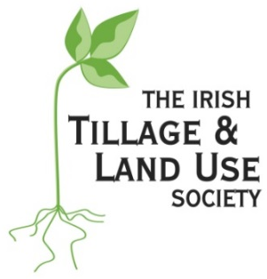
ITLUS / Rosenbohm
US Farm Internship
APPLICATION FORM

Name:
Address:
Phone numbers:
E-mail address:
Date of birth:
Agricultural qualifications:
Farming experience:
Other qualifications:
Skills with machinery:
Plant husbandry skills:
Hobbies:
Driver’s license: YES NO

Have you experienced agriculture in other countries?
What makes you the ideal candidate for this internship (max 250 words)?
How do you hope to benefit from this experience (max 250 words)?

What can American growers learn from the Irish Tillage sector (max 250 words)?
Computer skills?
Public speaking skills?
Signed:
Date:

